**nl4h%20header%202.pdf­­**

**At Risk of Extremism**

Questions and Notes

**Activities**

This Prezi can be used with a variety of activities depending on time available and the age/ability of the group. For example, you could:

* Ask the students to make a poster about extremism identifying, who is at risk, why and warning signs.
* Ask students to make notes throughout the presentation
* Undertake the activities below which are embedded in the Prezi (<https://prezi.com/embed/qawbfpu-xc0x/>)

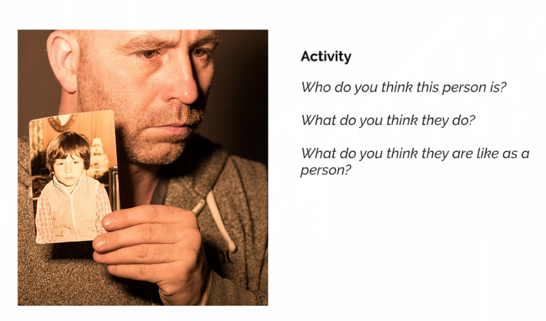

* Identify push and pull factors that lead a person towards extremism

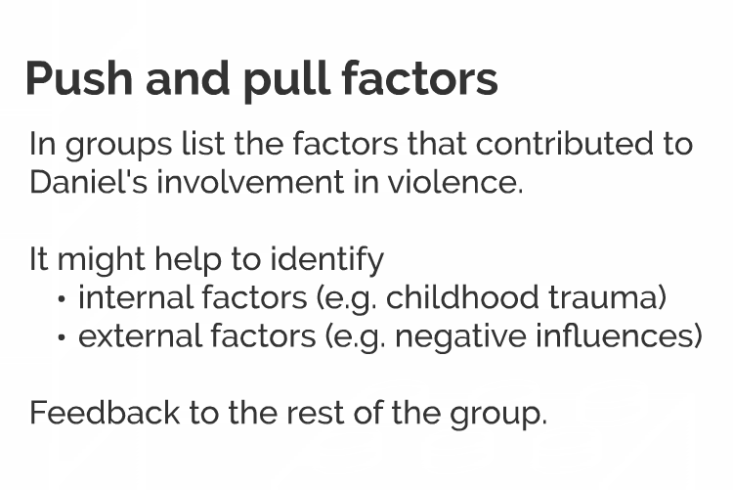

* Select one or more of the following questions to address in pairs or small groups and feedback to the class

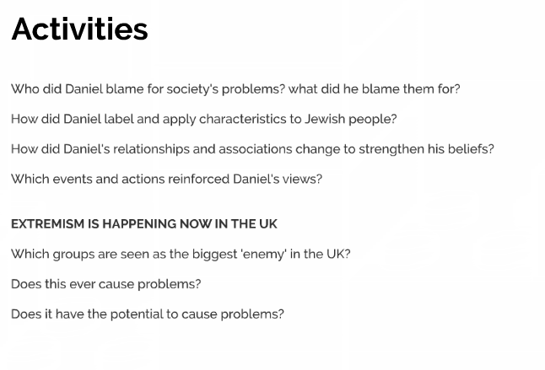

* Have a group discussion regarding messages from those who work to prevent radicalisation.

