About No Love for Hate
Launched in 2017, the No Love for Hate project aims to reduce the appeal of extremism to young people and offer a positive alternative to the increasing pressure they may feel from the world around them and the propaganda they may see online.
Dealing with violent extremism is not new. Our history demonstrates that there have been groups prepared to use violence to achieve their aims. Most recently we have faced threats from Irish terrorism, the radicalisation of people through a distorted interpretation of Islam and the threat from far-right-wing extremism. All of these affect individuals, families, colleges, schools and communities across the country and can be a catalyst for alienation and disaffection and potentially lead to violence.

A series of tutorials has been developed to challenge views and stimulate discussion. They include film clips and real life stories including; the story of Jo Cox who was murdered by a right-wing extremist, and Daniel Gallant a former member of a Canadian white supremacist group. The resources are open access materials, including Prezi presentations and Kahoot! quizzes, which can be adapted to meet the needs of a local audience. They can be found on Blendspace at https://www.tes.com/lessons/p0ogfHYlxdZLcw/no-love-for-hate.
The tutorials are complemented by a Theatre production, co-created by the How it Ended theatre group and students at Luton Sixth Form College. A film of the production is available on Blendspace. How it Ended theatre group offer workshop opportunities to colleges and schools across the UK. Students with learning differences and disabilities were supported by tutors and the Bedazzled Theatre group to script and perform their own play, a film of which is available on Blendspace.
The resources can be used with KS4, KS5 and adult learners in classrooms or community settings and are intended to be used to create a safe space for debating controversial issues and to build resilience to extremism. They are also supported by teachers’ resources which aim to give confidence in managing debates about contentious issues and to assist in the fulfilment of the Prevent duty in a proactive and positive way.
The project has been co-funded by the Home Office in partnership with Harlow College and Luton Sixth Form College. The Digital and Marketing teams at Harlow College have supported the development of the project.

Prevent and No Love for Hate
The issue of extremism, and how best to prevent it, is complex, sensitive, and questioned and debated. The Government’s approach to tackling extremism is set out in the Prevent Strategy. The strategy commits to challenging extremist ideas that can be used to legitimise terrorism, and to intervene to stop people moving from extremist groups into terrorist-related activity. Local authorities, the police, colleges, schools and universities and the wider public sector are all bound to support efforts to prevent extremism.

All Further Education Colleges have a duty to safeguard their students. Prevent is about educating our students to keep them both safe and within the law. The Prevent Duty is not about preventing students from having political and religious views, interests and concerns. It is about supporting our learners to use and exchange opinions and ideas, enabling debate as well as learning in non-extremist ways. The importance of debating controversial issues in a safe environment is an integral part of preparing young people to question extremist views. Tackling radicalisation is absolutely not about shutting down debate but rather is aimed at equipping young people with the critical thinking skills to identify and challenge extremist views. Teachers play a vital role in guiding and encouraging young people to build resilience to radicalisation and extremism. Colleges must ensure that they remain tolerant, welcoming and safe environments.

Preventing individuals from participating in, or supporting, the kinds of extremism that harms individuals, colleges and communities is critical. Extremism, particularly violent extremism, brings a serious challenge to society today. It has the potential to not only manifest itself in physical attacks on people and places, but to ruin lives, create a breakdown in relationships between communities and destroy individual and community reputations.

This Prevent Project seeks to prevent vulnerable individuals from being exploited and drawn into far-right extremist activity. This effort is most effective when staff have the confidence to deliver and implement Prevent, and when colleges trust and are engaged in the approach being taken. Extremist groups establish a narrative that is used to encourage people to support them. By engaging the person at risk in an open and honest debate about the issues and by delivering a strong and positive message, efforts to prevent extremism make a difference.

The internet has opened up new ways to promote extremism, playing a key role in changing the nature and extent of extremist activity in this country and overseas. It enables a wider range of organisations and individuals to reach a much larger audience with a broader and more dynamic series of messages and narratives. Previously, individuals would have had to join groups and attend meetings to be exposed to the views and concepts that promoted extremism. Now they can access such information from their phones and tablets from home. Extremist groups are increasingly using social media tools, such as Twitter, Facebook, WhatsApp and YouTube, to spread their message. They encourage interaction, for example through Facebook ‘Like’, .. to facilitate support. The way people use the internet also encourages radicalisation with people seeking out those whose views are similar to their own, encouraging group thinking and inhibiting external challenge.

Our Educational Resource
These tutorial materials, produced by students, staff and apprentices of Harlow College and Luton Sixth Form College address the underlying issues that can attract people towards violent extremist causes. The importance of engaging with young people is crucial if we are to make a difference to build mutual respect and understanding and reject fears based on ignorance or prejudice, extremism and violence in whatever form it takes.

Our materials will contribute towards
- equipping young people with the knowledge and skills to pause and think for themselves,
- to challenge and to debate,
- giving young people the opportunity to reflect on history, on the experiences of other students and their faiths and
- to gain an understanding of the values we share.

These materials enable students and staff to explore why extremist views do not fit into our British democratic views and the detrimental impact that this can have both on our society and globally.

Our project creates a tutorial resource that explains the issues of far-right extremism and which provides a framework for teaching staff engaged in preventing young people from radicalisation.

The sessions are designed to maximise participation and encourage openness through interaction, contribution and response.

These resources can be run as individual tutorial sessions or in a sequence to build knowledge, awareness, trust and shared learning. The outlines below provide:

- a brief overview of the session
- the age range targeted
- links to the resources and teacher support note
Session 1

Title: Groupings | Age-range: 14+
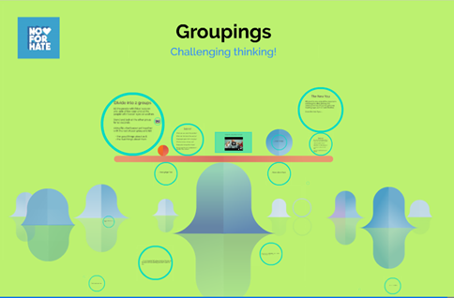 | These group activities and short film aim to challenge young people and their accepted thinking about the groups they associate and identify with.  The resource comprises of 2 challenging exercises which examine human behaviour and help young people identify how they perceive, accept and challenge views.  The ideas can be taken forward alongside the other resources when students think about how people become at risk of being radicalised.
Links: | Prezi presentation  Student activity sheet  Teacher notes

Session 2
Title: No Love for Hate | Age-range: 14+
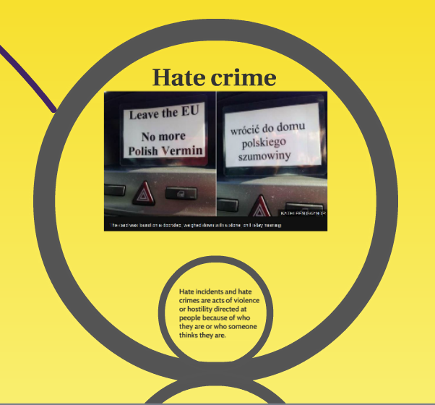 | This session introduces students to the definition of a hate crime. It provides visual stimuli, newspaper articles and video clips to help students identify hate incidents.  Right-wing extremism is introduced through real-life case studies, including the tragic murder of Jo Cox, MP for Batley and Spen in June 2016.  Students are asked to work in pairs to explain the characteristics of a hate crime, to analyse data and to consider the origins of right-wing extremism. Questions can be tailored depending on the age, level and ability of the group.
Links: | Prezi presentation  Student question worksheet  Lesson plan / teacher notes

Session 3
Title: Think before you click | Age-range: 14+
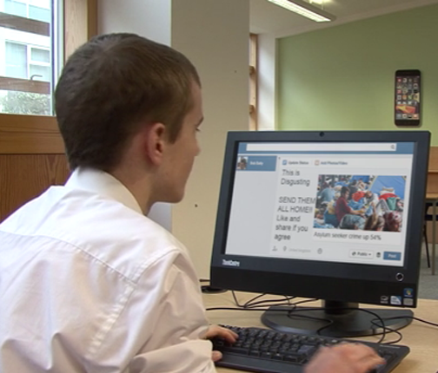 | This short video is designed to prompt discussion about the use of the internet and how we can ‘like’ things without knowing their origin.  There are organisations, for example, Britain First, who use clever social media campaigns to promote their views, often by using seemingly harmless subject matter.  This video was designed and filmed by Apprentices studying Digital Media at Harlow College.
Links: | Think! Before you click Youtube video (mp4)  Teacher notes

Session 4
Title: Pause II And Think! | Age-range: 14+
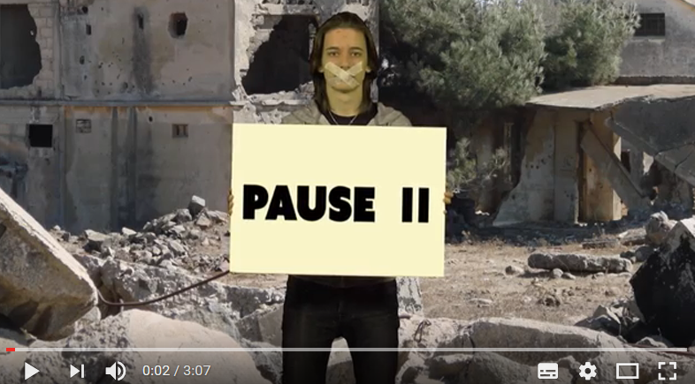 | This short video takes real stories from ESOL students at Harlow College who have travelled to the UK to escape war and violence in their country of origin.  It is interspersed with facts and figures to challenge misconceptions about refugees and asylum seekers.  This can be used in-conjunction with ‘Think before you click’ to discuss the influence of media and social media on opinion. Media and Social Media are often used cleverly by extremist organisations to fund hate campaigns and incite violence.
Links: | Pause II and Think Film (mp4)  PowerPoint with notes  Lesson Plan  Fact or myth worksheet  Quotations from ESOL students worksheet

Session 5
Title: The impact of migration on British Sport | Age-range: 14+
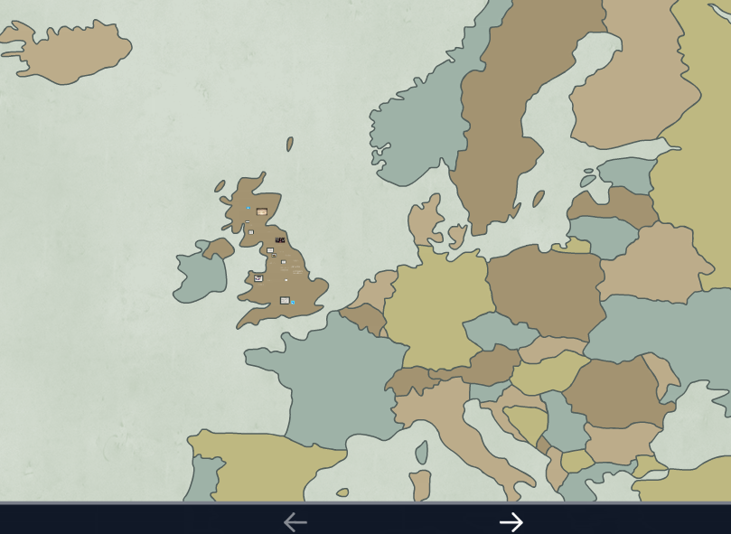 | This presentation looks at the topic of immigration through the lens of Sport.  It can be used to get students to challenge their concepts of British identity. It takes different sports, teams and events like the Olympics to examine how migration has had a positive impact on Sport.  You could revisit the media headlines used in session 4 to challenge negative views of immigration as part of the session.  As a follow-up you could ask the students to read the Guardian newspaper article (16+) or watch the following Chelsea football fan video (14+) and discuss.
Links: | Prezi presentation  Lesson plan / teacher notes  Guardian article: Man who pushed Polish man on to tube tracks jailed for 10 years [January 2017]  Telegraph article: Victim of Chelsea fans’ racist attack in Paris calls for jail sentences [February 2017]

Session 6
Title: Kahoot! | Age-range: 16+
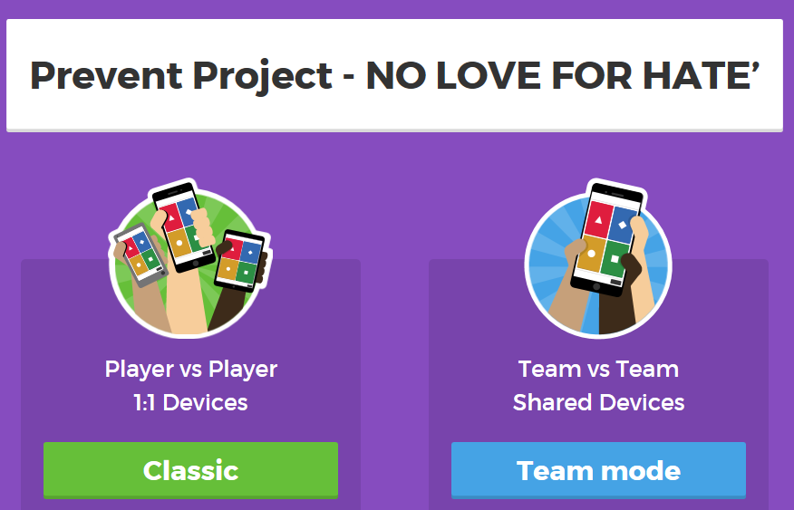 | This Kahoot! quiz is designed to be used in an interactive way. Students join the Kahoot! group and identify their emotions, feelings and views on a range of statements, videos and real-life case studies.  The quiz draws on recent events in Harlow and also the UK to get students to think about right-wing extremism and the impact it has had on their daily lives.  As a teacher you can question responses as you go through and have a group discussion or undertake the quiz and then discuss.
Links: | Kahoot! interactive quiz (QR code)  ‘How to Guide’  Lesson Plan

Session 7
Title: At Risk of Extremism | Age-range: 16+
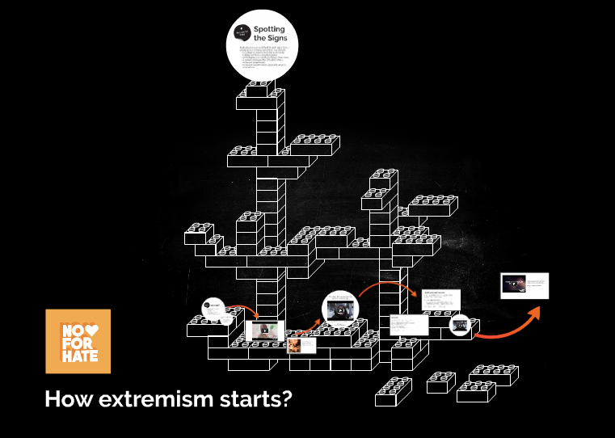 | You should familiarise yourself with the content of the videos and the Prezi before you start.  This presentation uses hard-hitting films produced by the Extreme dialogue project to tell the story of Daniel Gallant a former Canadian white supremacist group member.  Students are asked to identify characteristics of those at-risk of extremism and to look at the push/pull factors that cause a person to become radicalised.
Links: | Prezi presentation (note: student questions embedded in Prezi)  Teacher notes

Session 8
Title: Tomorrow belongs to you | Age-range: 16+
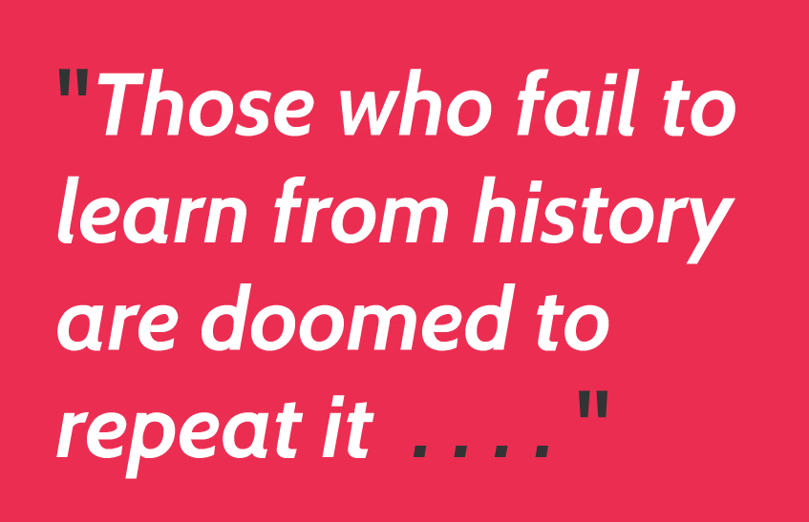 | This Prezi looks back in History at the rise of right-wing extremism and fascist groups.  It identifies the rise of populism and how people blamed minorities, legitimising hate.  It draws parallels with history and asks students to challenge their views on what could happen in the future.
Links: | Prezi presentation  Student question sheet  Lesson Plan / teacher notes

Session 9
Title: The No Love for Hate Show | Age-range: 16+
A film by the Supported Studies students working with Bedazzle Performing Arts which examines the attitudes of young people towards migrants and refugees seeking employment.

The film is shown from the perspective of a talk show including the views of members of the studio audience and a re-enactment of an incident at a Job Centre.

Questions are raised over people’s attitudes and how this may result in intolerant and violent behaviour towards migrant workers.
Links: | No love for hate show film (mp4)

Theatre productions
Students at both colleges were supported by Theatre groups to produce performances and DVDs. These were co-scripted to allow the students to develop their own ideas and creative narrative linked to the Prevent message.
How it Ended worked with Luton Sixth Form College. Described by Fest Magazine as "ones to watch", How It Ended is a theatre company based in Luton. How It Ended is run by co-artistic directors Eva Sampson and Teresa Burns, who met whilst studying Drama at the University of Birmingham. How It Ended make work that explores the highs, lows and complexities of life, with an aim to make ambitious pieces of theatre that are youthful, contemporary and exciting. Through new writing, original music and visual storytelling How It Ended work to excite young audiences and inspire the next generation of theatre makers. How It Ended's recent productions include: The Little Gardner (National Theatre and UK Tour) Roll Credits (Rich Mix / Ideastap LOVE Takeover), FUTURESPARK (UK Centre for Carnival Arts), You Obviously Know What I'm Talking About (Theatre503/Underbelly/The Hat Factory), Waterproof (Pleasance /Site specific), Kindness on the Northern Line (BAC).
Website: https://www.howitended.org/
Bedazzle Performing Arts worked with Supported Studies students at Harlow College.
Bedazzle are a charity dedicated to the advancement of education in the performing arts, with particular emphasis on those who are disadvantaged or have disabilities.

‘Bedazzle Projects’ is a registered charity that was set-up in March 2011 with the aim of attracting funding for all (particularly children and young people) allowing them access to a wide range of performing arts activities.

Bedazzle’s ‘all inclusive’ policy attracted an approach by Cambridgeshire Mencap in 2011 to take over its existing ‘youth group’ with the express desire of focusing on theatre arts. The initiative was an immediate success. In addition to singing, dancing and acting skills; the course also included arts & crafts sessions. The group comprises of students aged 8 to 26, most with Down’s Syndrome; others with ASD (Autism Spectrum Disorder) and a few with non-specified learning difficulties resulting from physical injury or ill health. A second group was opened in May 2010, based in Huntingdon.

Although Bedazzle offers performing arts as key disciplines, its primary aims are to ‘instil Confidence’, ‘inspire Creativity’ and ‘increase Communication Skills’. The three key skills that complement mainstream education syllabuses. Bedazzle have been working with Harlow College since 2016.

