**­­**

**Lesson Plan / Teacher’s Notes for Prezi**

“Tomorrow Belongs to You”

**Objectives**

Learners should understand some of the following:-

* That the economic events of 1929 caused right wing extremist groups to become popular and legitimise hate.
* That this lead to a World War killing 60 million people.
* That the German Nazi party murdered 5.9 million Jews, 0.75 million Gypsies, 0.25 million disabled people, 15,000 homosexuals and 5,000 Jehovah Witnesses.
* That similar economic events in 2008 have led to right wing extremist groups to become popular again NOW - who are once again legitimising hate.
* That “ … those who fail to learn from history are doomed to repeat it….”.

Note

1. The teacher should watch the Prezi™ (<https://www.tes.com/lessons/p0ogfHYlxdZLcw/no-love-for-hate>) and read through the accompanying Learning Materials prior to the lesson. Allow ½ an hour.
2. The teacher should check understanding of the vocabulary list below before playing the Prezi™
3. If the teacher cannot get the Prezi™ to run WITH ITS MUSICAL SCORE then s/he should abandon the tutorial and do something else.
4. The teacher should share the following Learning Outcomes with the class.

Learning Outcomes

By the end of this Tutorial you will be able to describe or explain:-

1. How an economic recession can lead to life-shifting catastrophic events.
2. Why an economic recession can cause extreme right-wing groups to become popular.
3. The life changing events that happened during your grandparents’ lives.
4. Why the rise of extreme right wing groups can lead to hate.

Vocabulary that learners will need acquire

* Economic
* Recession
* Extremist
* Right-Wing
* Fascism
* legitimise
* Democratic
* Dictator
* Nazi
* Appeasement

Lesson Plan

|  |  |  |
| --- | --- | --- |
| Time | Learners will:- | Resources |
| Start | Understand learning outcomes through teacher led Q&A | Whiteboard / LO’s |
| 10 | Understand key vocabulary needed through teacher led Q&A | Whiteboard / Vocab list (see below) |
| 20 | Watch Prezi™ | Prezi™ |
| 40 | Check their understanding of key points within Prezi through teacher led TARGETED Q&A. | Whiteboard  Freeze frame key Prezi slides |
| 50 | In pairs discuss and complete learning materials. | Word ™ handout |
| 70 | Tell partner what they have learnt. | Learners |
| 75 | Feedback what their partner has learnt. | Learners |

~ ~ ~ END ~ ~ ~



**Worksheet**

Tomorrow Belongs to You

* **Discuss and answer the following questions in pairs and NOT in groups.**
* **Your teacher may want you to research some of the issues using your phones or on line devices and s/he may want to discuss the questions with you.**

1. Who said, “Those who fail to learn from history are doomed to repeat it?”

……………………………………………………………………………………………………………………………………………………………………………………………………………….…..

1. Was he a Historian?

……………………………………………………………………………………………………………………………………………………………………………………………………………….…..

1. When was the first Wall Street Crash?

……………………………………………………………………………………………………………………………………………………………………………………………………………….…..

1. What did it cause?

……………………………………………………………………………………………………………………………………………………………………………………………………………….…..

1. Why does long term economic recession cause extreme right wing politics to become more popular?

……………………………………………………………………………………………………………………………………………………………………………………………………………….…..

……………………………………………………………………………………………………………………………………………………………………………………………………………….…..

……………………………………………………………………………………………………………………………………………………………………………………………………………….…..

1. Why do people with ultra-right wing views hate?

……………………………………………………………………………………………………………………………………………………………………………………………………………….…..

……………………………………………………………………………………………………………………………………………………………………………………………………………….…..

1. Why do they hate them?

……………………………………………………………………………………………………………………………………………………………………………………………………………….…..

……………………………………………………………………………………………………………………………………………………………………………………………………………….…..

1. Who was this man?

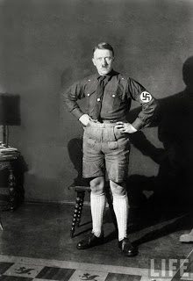

……………………………………………………………………………………………………………………………………………………………………………………………………………….…..

1. What was he in charge of?

……………………………………………………………………………………………………………………………………………………………………………………………………………….…..

1. Was he democratically elected or did he seize power as a dictator?

……………………………………………………………………………………………………………………………………………………………………………………………………………….…..

1. Name three things he did.

……………………………………………………………………………………………………………………………………………………………………………………………………………….…..

……………………………………………………………………………………………………………………………………………………………………………………………………………….…..

……………………………………………………………………………………………………………………………………………………………………………………………………………….…..

1. Do you think history repeats itself?

……………………………………………………………………………………………………………………………………………………………………………………………………………….…..

1. Is there any evidence that it does?

……………………………………………………………………………………………………………………………………………………………………………………………………………….…..

……………………………………………………………………………………………………………………………………………………………………………………………………………….…..

……………………………………………………………………………………………………………………………………………………………………………………………………………….…..

1. Explain why these two pictures suggest history may be repeating itself.

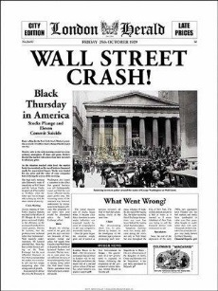

……………………………………………………………………………………………………………………………………………………………………………………………………………….…..

……………………………………………………………………………………………………………………………………………………………………………………………………………….…..

……………………………………………………………………………………………………………………………………………………………………………………………………………….…..

1. Explain why these two pictures suggest history may be repeating itself.

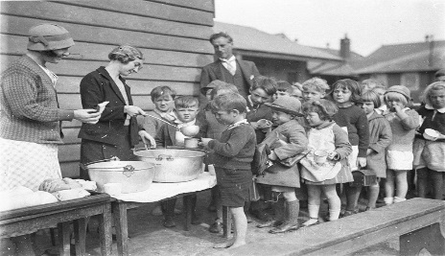

……………………………………………………………………………………………………………………………………………………………………………………………………………….…..

……………………………………………………………………………………………………………………………………………………………………………………………………………….…..

……………………………………………………………………………………………………………………………………………………………………………………………………………….…..

1. Explain why these two pictures suggest history may be repeating itself.

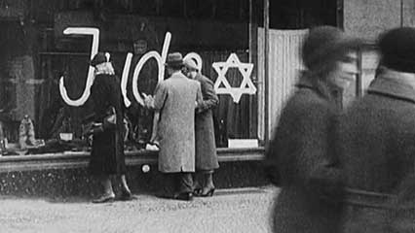

……………………………………………………………………………………………………………………………………………………………………………………………………………….…..

……………………………………………………………………………………………………………………………………………………………………………………………………………….…..

1. Political Scientists say that right wing dictators share three common behaviour traits: -

* They play fast and loose with the truth so you don’t know what is true and what is not anymore. (*Hitler wrote about the power of the big lie. If you tell a huge whopper people are more likely to believe* you).
* They ignore the rule of law (the rule of law means that nobody, not even the Prime Minister or the Queen, is above the law and that the courts and the judges are independent of the government – the Prime Minister can’t tell the courts what to do. *Hitler brought in his own instant laws and made the courts enforce them even though they were illegal*.)
* They tell the people that it is the strength of their personality alone that will make things better rather than having well thought-out policies.

1. Are there any leaders like that in other countries that don’t have?

……………………………………………………………………………………………………………………………………………………………………………………………………………….………

1. Do you think we could ever see another leader like that in a democratic country?

……………………………………………………………………………………………………………………………………………………………………………………………………………….………

1. Who was this lady?



……………………………………………………………………………………………………………………………………………………………………………………………………………….…..

1. What was significance about the date on which she was murdered?

……………………………………………………………………………………………………………………………………………………………………………………………………………….…..

1. Who is this man below? Where was he when he held up this piece of paper? Who had he been to see and what was he saying?

……………………………………………………………………………………………………………………………………………………………………………………………………………….…..

……………………………………………………………………………………………………………………………………………………………………………………………………………….…..

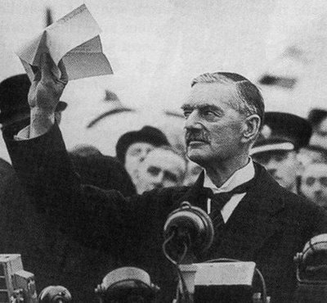

1. What does appeasement mean?

……………………………………………………………………………………………………………………………………………………………………………………………………………….…..

……………………………………………………………………………………………………………………………………………………………………………………………………………….…..

1. What’s the difference between the word *appease* and the word *tolerate*?

……………………………………………………………………………………………………………………………………………………………………………………………………………….…..

1. What have you learnt today that you didn’t know before?

……………………………………………………………………………………………………………………………………………………………………………………………………………….…..

……………………………………………………………………………………………………………………………………………………………………………………………………………….…..

……………………………………………………………………………………………………………………………………………………………………………………………………………….…..

……………………………………………………………………………………………………………………………………………………………………………………………………………….…..

……………………………………………………………………………………………………………………………………………………………………………………………………………….…..